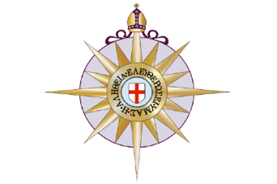

***ANGLICAN CHURCH OF THE MESSIAH, PLAINFIELD, NEW JERSEY***

**APPLICATION FOR HOLY BAPTISM**

**Child’s Names**:_________________________________________________________________________

**Last Name**:____________________________________________________________________________

**Child’s Date of Birth**:____________________________________________________________________

**Place of Birth**:_________________________________________________________________________

**Father’s Full Name**:_____________________________________________________________________

**Mother’s Full Name**:____________________________________________________________________

**Address**:______________________________________________________________________________

**Telephone:**____________________________________________________________________________

**Father’s Occupation**:____________________________________________________________________

**Mother’s Occupation**:___________________________________________________________________

**GODPARENTS:**

1.___________________________________________________________________________________

2.___________________________________________________________________________________

3.___________________________________________________________________________________

**Father’s Signature**:_____________________________ **Mother’s Signature**:______________________

CHURCH OFFICIAL ONLY

*DATE OF BAPTISM*:……………………………………………………………………………………………..

PASTOR’S COMMENT:………………………………………………………………………………………..

***Jesus said, “Let the little children come to me, and do not hinder them, for the kingdom of Heaven belongs to such as these.” Matthew 19:14***